EXP NO 1: Implement a C Program for Reversing a 32 bit signed integers
#include <stdio.h>
#include <limits.h>
int reverse_int(int x) {
long long rev = 0;
while (x != 0) {
int digit = x % 10;
rev = rev * 10 + digit;
if (rev > INT_MAX || rev < INT_MIN) return 0; // overflow
x /= 10;
}
return (int)rev;
}
int main() {
int n;
printf("Enter 32-bit signed integer: ");
if (scanf("%d", &n) != 1) return 0;
int r = reverse_int(n);
if (r == 0) printf("Reversed value is 0 (possible overflow or original reversed to 0).\n");
else printf("Reversed: %d\n", r);
return 0;
}
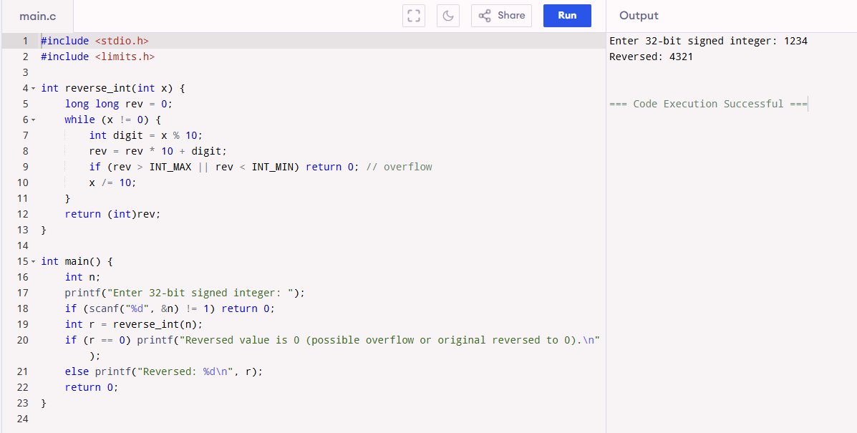

EXP NO 2: Implement a C Program to Check for a valid String
#include <stdio.h>
#include <ctype.h>
#include <string.h>
int is_valid_string(const char *s) {
for (int i = 0; s[i]; ++i) {
if (!(isalpha((unsigned char)s[i]) || isspace((unsigned char)s[i]))) return 0;
}
return 1;
}
int main() {
char buf[1024];
printf("Enter string: ");
if (!fgets(buf, sizeof(buf), stdin)) return 0;
// remove newline
buf[strcspn(buf, "\n")] = 0;
if (is_valid_string(buf)) printf("Valid string (letters and spaces only).\n");
else printf("Invalid string (contains non-letters/non-space characters).\n");
return 0;
}
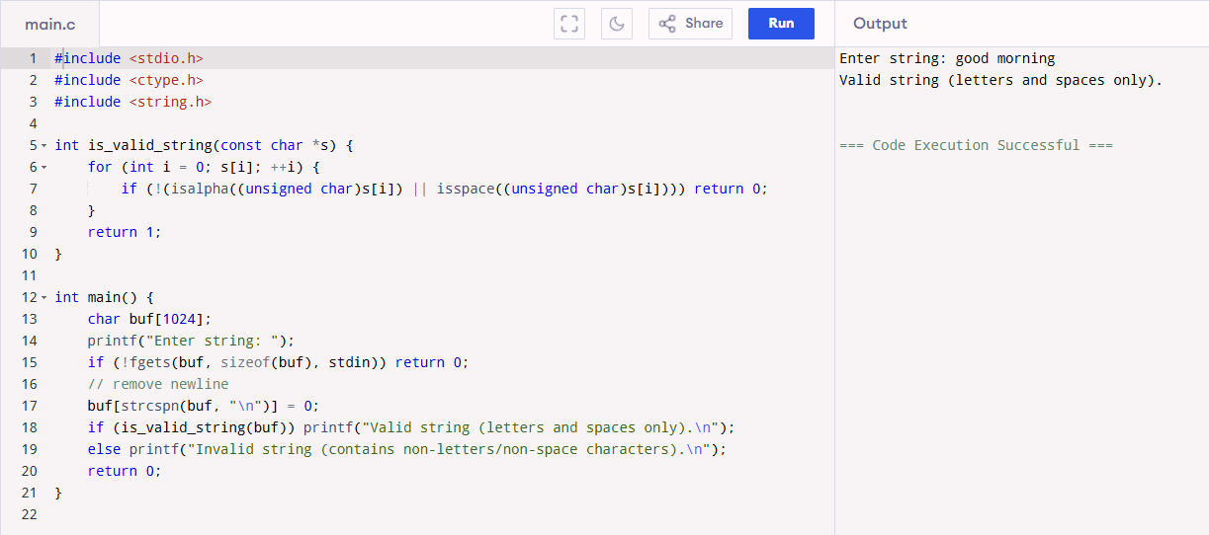
EXP NO 3:- earch for a particular registration number in an array[LINEAR SEARCH]
#include <stdio.h>
#include <string.h>
int main() {
int n;
printf("Enter number of registration numbers: ");
scanf("%d", &n);
char regs[n][100];
for (int i = 0; i < n; i++) {
printf("Reg no %d: ", i + 1);
scanf("%s", regs[i]);
}
char key[100];
printf("Enter registration number to search: ");
scanf("%s", key);
int found = 0;
for (int i = 0; i < n; i++) {
if (strcmp(regs[i], key) == 0) {
printf("Found at index %d (0-based)\n", i);
found = 1;
break;
}
}
if (!found)
printf("Not found\n");
return 0;
}

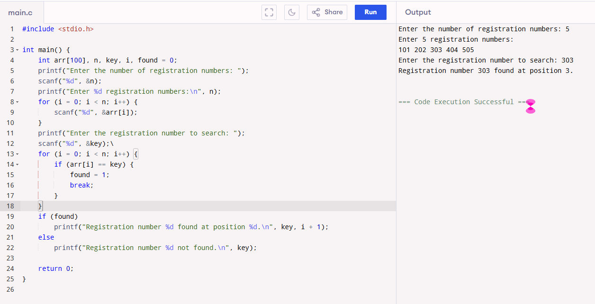

EXP NO 4: Search for a particular registration number in an array[BINARY SEARCH]
#include <stdio.h>
#include <string.h>
int main() {
int n;
printf("Enter number of registration numbers: ");
scanf("%d", &n);
char regs[n][100];
printf("Enter registration numbers (sorted order):\n");
for (int i = 0; i < n; i++) {
printf("Reg no %d: ", i + 1);
scanf("%s", regs[i]);
}
char key[100];
printf("Enter registration number to search: ");
scanf("%s", key);
int low = 0, high = n - 1, found = 0;
while (low <= high) {
int mid = (low + high) / 2;
int cmp = strcmp(key, regs[mid]);
if (cmp == 0) {
printf("Found at index %d (0-based)\n", mid);
found = 1;
break;
} else if (cmp > 0)
low = mid + 1;
else
high = mid - 1;
}
if (!found)
printf("Not found\n");
return 0;
}

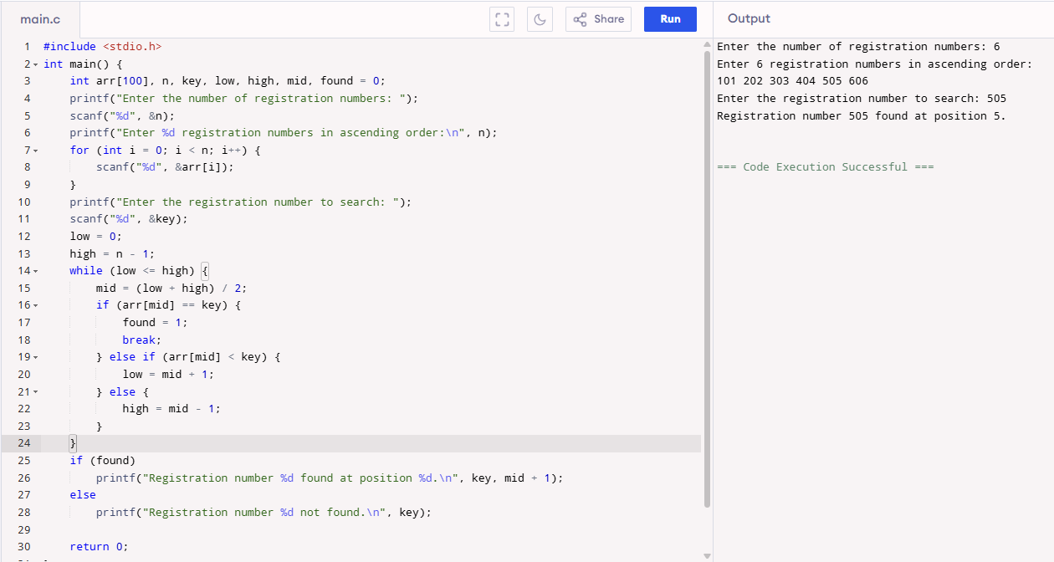

EXP NO 6:- . Implement a C Program Given array print odd and even values
#include <stdio.h>
int main() {
int n;
printf("Number of elements: ");
if (scanf("%d", &n) != 1 || n <= 0) return 0;
int a[n];
for (int i = 0; i < n; ++i) scanf("%d", &a[i]);
printf("Even numbers: ");
for (int i = 0; i < n; ++i) if (a[i] % 2 == 0) printf("%d ", a[i]);
printf("\nOdd numbers: ");
for (int i = 0; i < n; ++i) if (a[i] % 2 != 0) printf("%d ", a[i]);
printf("\n");
return 0;
}
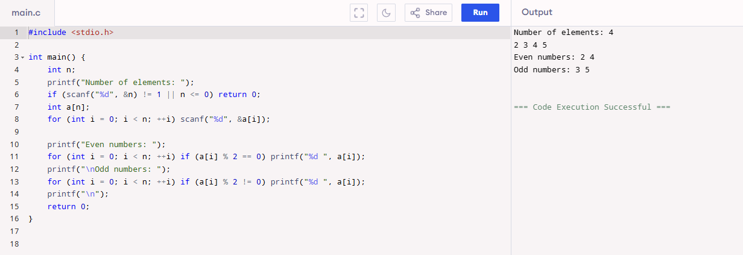

EXP NO 5:-Implement a C Program Identify location of element in given array
#include <stdio.h>

int main() {
int n;
printf("Enter number of elements: ");
if (scanf("%d", &n) != 1 || n <= 0) return 0;
int a[n];
for (int i = 0; i < n; ++i) {
printf("a[%d]: ", i);
scanf("%d", &a[i]);
}
int key;
printf("Enter element to find: ");
scanf("%d", &key);
int found = 0;
for (int i = 0; i < n; ++i) {
if (a[i] == key) {
printf("Element %d found at index %d\n", key, i);
found = 1;
break; // remove break to print all occurrences
}
}
if (!found) printf("Element not found\n");
return 0;
}
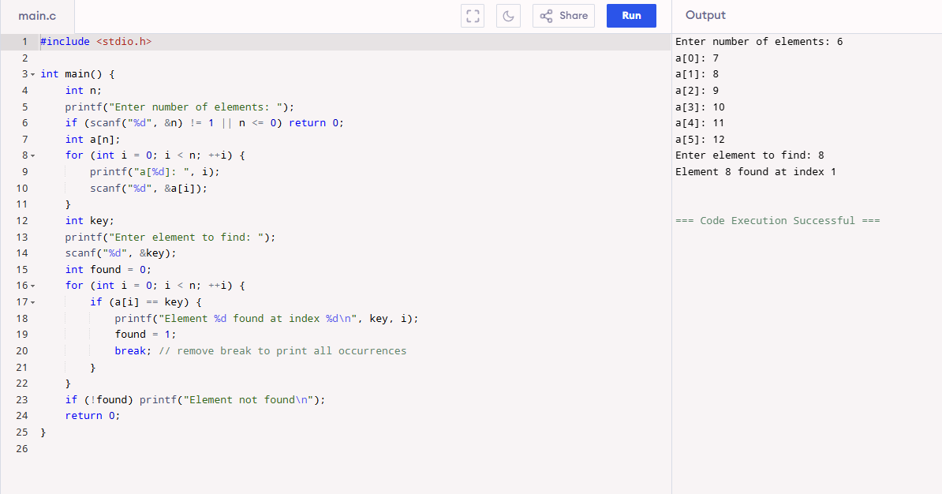

EXP NO 7:- Implement a C Program sum of Fibonacci Series

#include <stdio.h>
int main() {
int n;
printf("Enter number of Fibonacci terms (n >= 1): ");
if (scanf("%d", &n) != 1 || n < 1) return 0;
long long a = 0, b = 1;
long long sum = 0;
if (n >= 1) sum += a; // include F0 if desired; if you want starting at F1 change accordingly
if (n >= 2) sum += b;
for (int i = 3; i <= n; ++i) {
long long c = a + b;
sum += c;
a = b; b = c;
}
printf("Sum of first %d Fibonacci terms = %lld\n", n, sum);
return 0;
}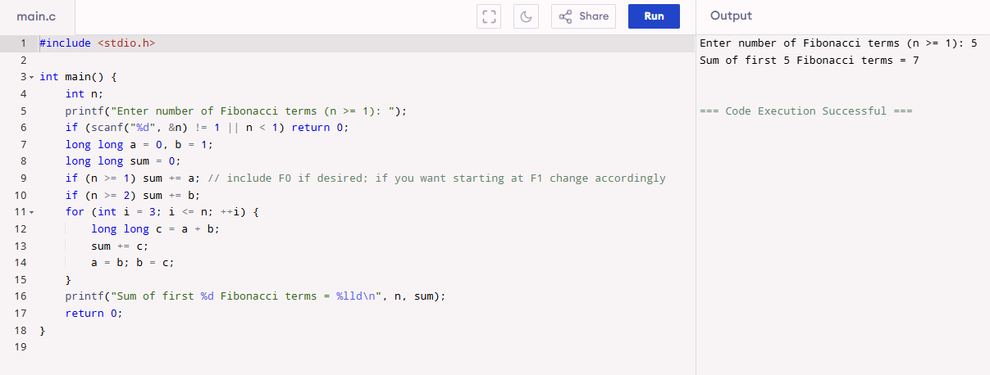
EXP NO 8:- Implement a C Program for Finding factorial of a number
#include <stdio.h>
unsigned long long factorial(unsigned int n) {
unsigned long long res = 1;
for (unsigned int i = 2; i <= n; ++i) res *= i;
return res;
}
int main() {
unsigned int n;
printf("Enter non-negative integer: ");
if (scanf("%u", &n) != 1) return 0;
printf("%u! = %llu\n", n, factorial(n));
return 0;
}
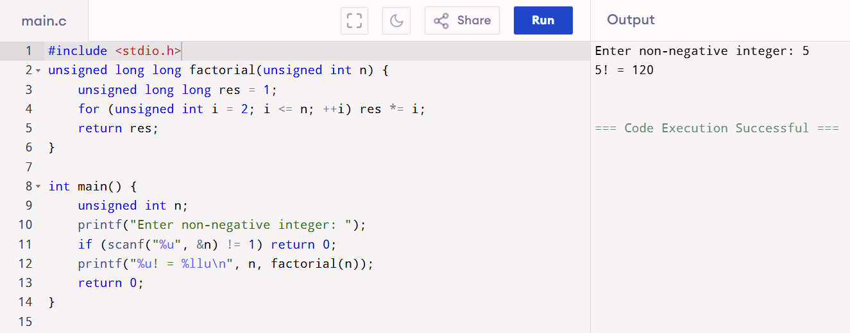

EXP NO 9:- Implement a C Program to Print the index of repeated characters given in an array
#include <stdio.h>
#include <string.h>
int main() {
char s[1024];
printf("Enter string: ");
if (!fgets(s, sizeof(s), stdin)) return 0;
s[strcspn(s, "\n")] = 0;
int len = strlen(s);
int printed[256] = {0};
for (int ch = 0; ch < 256; ++ch) {
int count = 0;
for (int i = 0; i < len; ++i) if ((unsigned char)s[i] == ch) ++count;
if (count > 1) {
printf("Character '%c' repeats at indices: ", (char)ch);
for (int i = 0; i < len; ++i) {
if ((unsigned char)s[i] == ch) printf("%d ", i);
}
printf("\n");
}
}
return 0;
}
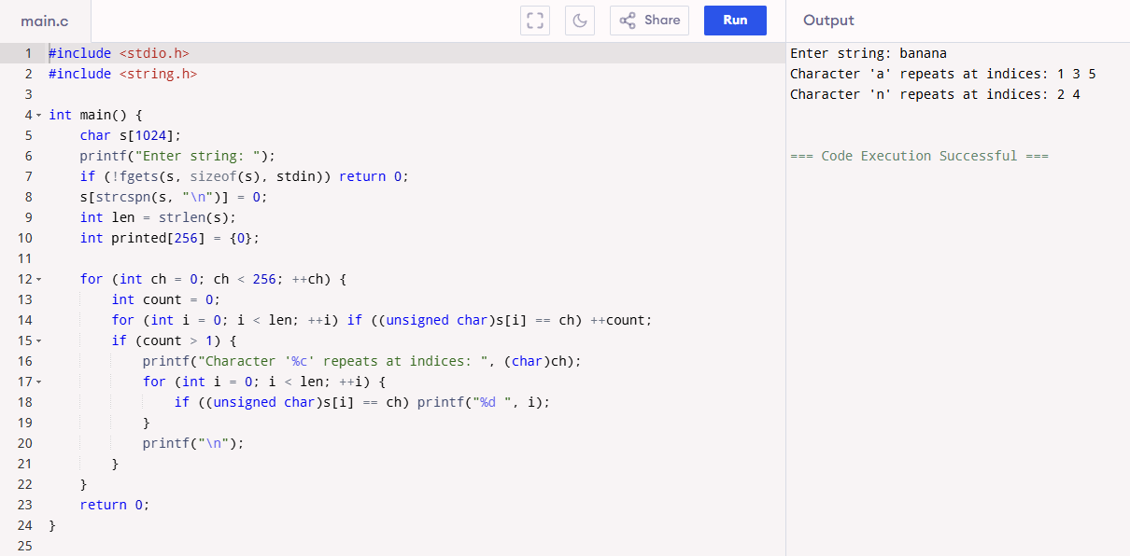

EXP NO 10:- Implement a C Program to Print the frequently repeated numbers count from an array
#include <stdio.h>
#include <stdlib.h>
int cmp_int(const void *a, const void *b) {
return (*(int*)a) - (*(int*)b);
}
int main() {
int n;
printf("Enter number of elements: ");
if (scanf("%d", &n) != 1 || n <= 0) return 0;
int *a = malloc(n * sizeof(int));
for (int i = 0; i < n; ++i) scanf("%d", &a[i]);
qsort(a, n, sizeof(int), cmp_int);
int i = 0;
int found_any = 0;
while (i < n) {
int j = i + 1;
while (j < n && a[j] == a[i]) ++j;
int count = j - i;
if (count > 1) {
printf("Number %d repeats %d times\n", a[i], count);
found_any = 1;
}
i = j;
}
if (!found_any) printf("No repeated numbers\n");
free(a);
return 0;
}
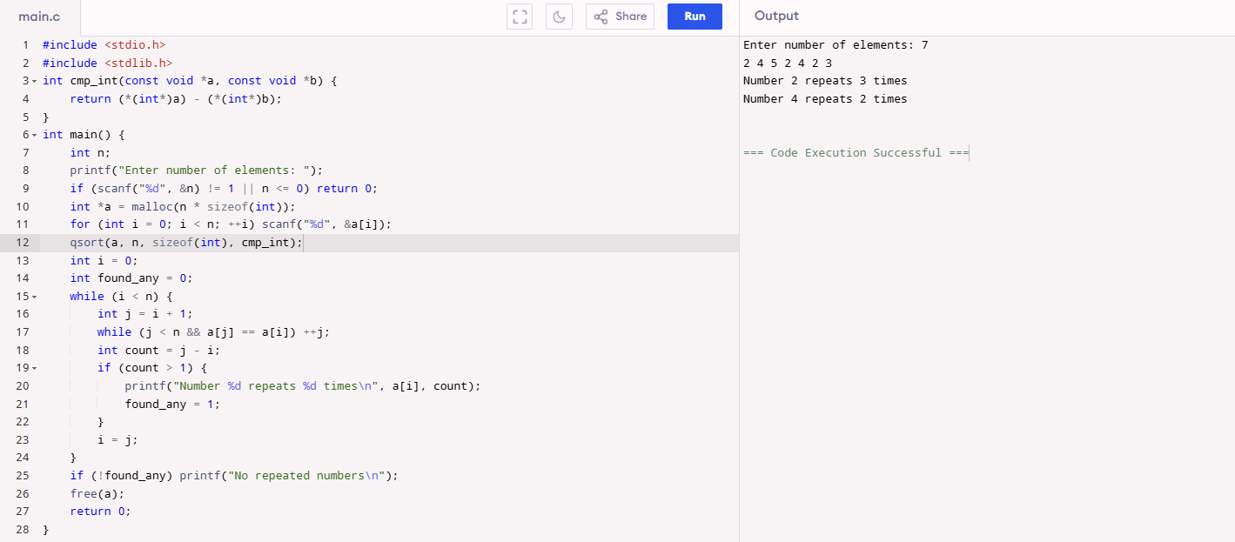
EXP NO 11:- . Implement a C Program to perform Sum of row and column in an Array
#include <stdio.h>
#include <stdlib.h>
int main() {
int r, c;
printf("Enter rows and columns: ");
if (scanf("%d %d", &r, &c) != 2 || r <= 0 || c <= 0) return 0;
int **mat = malloc(r * sizeof(int*));
for (int i = 0; i < r; ++i) mat[i] = malloc(c * sizeof(int));
printf("Enter matrix elements row-wise:\n");
for (int i = 0; i < r; ++i)
for (int j = 0; j < c; ++j)
scanf("%d", &mat[i][j]);
for (int i = 0; i < r; ++i) {
long long sum = 0;
for (int j = 0; j < c; ++j) sum += mat[i][j];
printf("Sum of row %d = %lld\n", i, sum);
}
for (int j = 0; j < c; ++j) {
long long sum = 0;
for (int i = 0; i < r; ++i) sum += mat[i][j];
printf("Sum of column %d = %lld\n", j, sum);
}
for (int i = 0; i < r; ++i) free(mat[i]);
free(mat);
return 0;
}
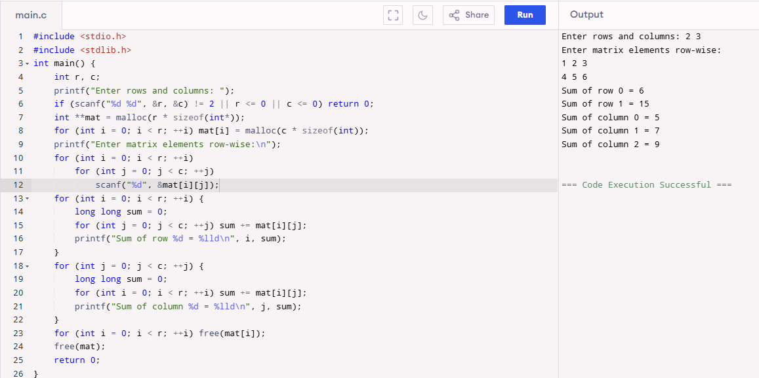
EXP NO 12:- . Implement a C Program to check for Elements repeated twice – Array
#include <stdio.h>
#include <stdlib.h>
int cmp_int(const void *a, const void *b) { return (*(int*)a) - (*(int*)b); }
int main() {
int n;
printf("Enter number of elements: ");
if (scanf("%d", &n) != 1 || n <= 0) return 0;
int *a = malloc(n * sizeof(int));
for (int i = 0; i < n; ++i) scanf("%d", &a[i]);
qsort(a, n, sizeof(int), cmp_int);
int i = 0;
int found = 0;
while (i < n) {
int j = i + 1;
while (j < n && a[j] == a[i]) ++j;
int count = j - i;
if (count == 2) {
printf("Element %d appears exactly twice\n", a[i]);
found = 1;
}
i = j;
}
if (!found) printf("No element appears exactly twice\n");
free(a);
return 0;
}
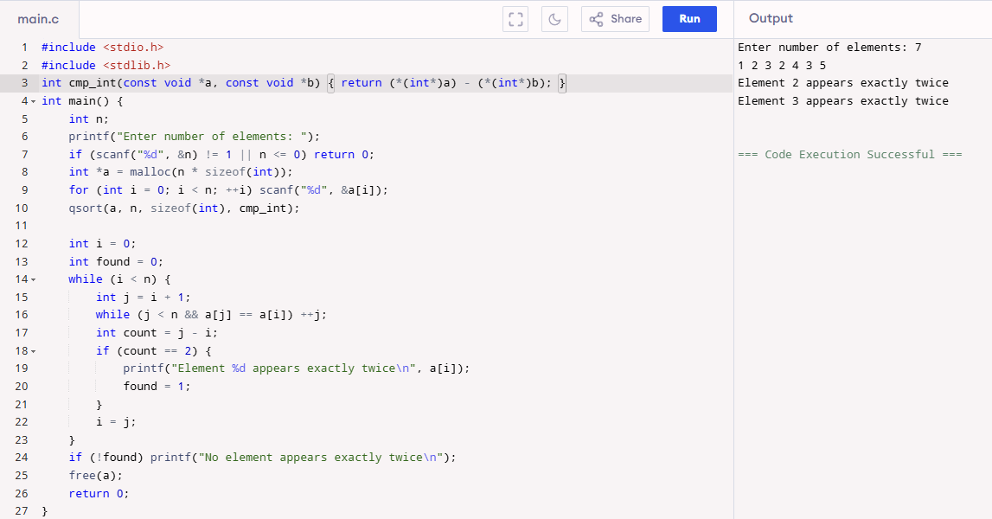
EXP NO 13:- A Implement a C Program for array search - linear and binary search
#include <stdio.h>
int linear_search(int a[], int n, int key) {
for (int i = 0; i < n; ++i) if (a[i] == key) return i;
return -1;
}
int binary_search(int a[], int n, int key) {
int lo = 0, hi = n - 1;
while (lo <= hi) {
int mid = lo + (hi - lo) / 2;
if (a[mid] == key) return mid;
else if (a[mid] < key) lo = mid + 1;
else hi = mid - 1;
}
return -1;
}
int main() {
int n;
printf("Enter number of elements: ");
if (scanf("%d", &n) != 1 || n <= 0) return 0;
int a[n];
printf("Enter elements (for binary search: enter sorted ascending array):\n");
for (int i = 0; i < n; ++i) scanf("%d", &a[i]);
int key;
printf("Enter key to search: ");
scanf("%d", &key);
int li = linear_search(a, n, key);
if (li >= 0) printf("Linear search: found at index %d\n", li);
else printf("Linear search: not found\n");
int bi = binary_search(a, n, key);
if (bi >= 0) printf("Binary search: found at index %d\n", bi);
else printf("Binary search: not found (ensure array is sorted)\n");
return 0;
}

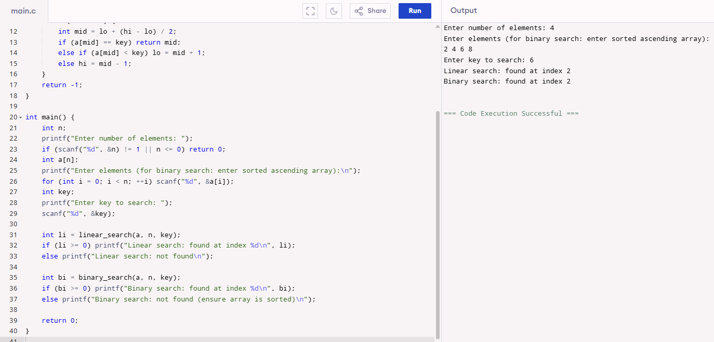
EXP NO 14:- Implement a C Program for Given 2 D matrix to print largest element
#include <stdio.h>
#include <limits.h>
#include <stdlib.h>
int main() {
int r, c;
printf("Enter rows and columns: ");
if (scanf("%d %d", &r, &c) != 2 || r <= 0 || c <= 0) return 0;
int maxv = INT_MIN;
printf("Enter matrix elements row-wise:\n");
for (int i = 0; i < r; ++i)
for (int j = 0; j < c; ++j) {
int v;
scanf("%d", &v);
if (v > maxv) maxv = v;
}
printf("Largest element = %d\n", maxv);
return 0;
}
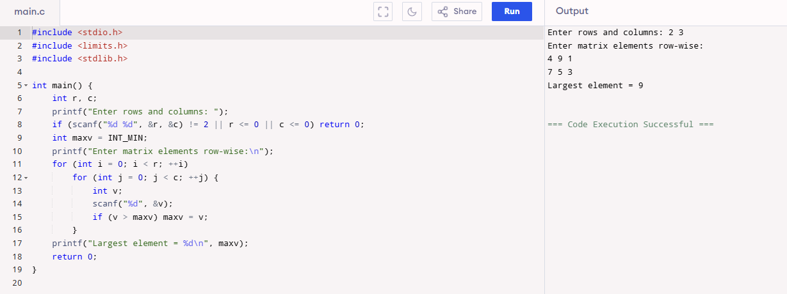
EXP NO 15: 3D MULTIPLICATION,ADD,SUB,TRANSPOSE
EXP NO 16: C PROGRAM TO IMPLEMENT A SINGLE LINKED LIST
#include <stdio.h>
#include <stdlib.h>
struct Node {
int data;
struct Node *next;
};
int main() {
struct Node *head = NULL, *temp, *newnode;
int n, value;
printf("Enter number of nodes: ");
scanf("%d", &n);
for (int i = 0; i < n; i++) {
newnode = (struct Node *)malloc(sizeof(struct Node));
printf("Enter data for node %d: ", i + 1);
scanf("%d", &value);
newnode->data = value;
newnode->next = NULL;
if (head == NULL)
head = newnode;
else {
temp = head;
while (temp->next)
temp = temp->next;
temp->next = newnode;
}
}
printf("Linked List: ");
temp = head;
while (temp) {
printf("%d -> ", temp->data);
temp = temp->next;
}
printf("NULL\n");
return 0;
}
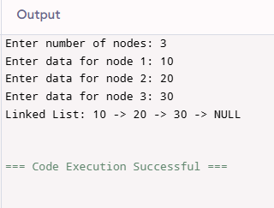
EXP NO17: WRITE A C PROGRAM TO IMPLEMENT STACK OPERATION IN ARRAY[PUSH]
#include <stdio.h>
#define MAX 5
int stack[MAX], top = -1;
void push(int val) {
if (top == MAX - 1)
printf("Stack Overflow\n");
else {
top++;
stack[top] = val;
printf("%d pushed into stack\n", val);
}
}
int main() {
int val;
printf("Enter value to push: ");
scanf("%d", &val);
push(val);
return 0;
}
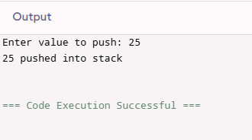
EXP NO18: WRITE A C PROGRAM TO IMPLEMENT STACK OPERATIONIN ARRAY[POP]
#include <stdio.h>
#define MAX 5
int stack[MAX] = {10, 20, 30}, top = 2;

void pop() {
if (top == -1)
printf("Stack Underflow\n");
else
printf("Popped element: %d\n", stack[top--]);
}

int main() {
pop();
return 0;
}
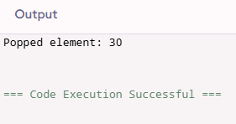
EXP NO19: WRITE A C PROGRAM TO IMPLEMENT STACK OPERATION IN ARRAY[DISPLAY]
#include <stdio.h>
#define MAX 5
int stack[MAX] = {10, 20, 30}, top = 2;

void display() {
if (top == -1)
printf("Stack is empty\n");
else {
printf("Stack elements: ");
for (int i = top; i >= 0; i--)
printf("%d ", stack[i]);
printf("\n");
}
}

int main() {
display();
return 0;
}
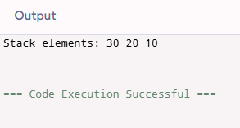
EXP NO20: WRITE A C PROGRAM TO IMPLEMENT STACK OPERATION IN LINKED LIST[PUSH]
#include <stdio.h>
#include <stdlib.h>
struct Node {
int data;
struct Node *next;
};
struct Node *top = NULL;
void push(int val) {
struct Node *newnode = (struct Node *)malloc(sizeof(struct Node));
newnode->data = val;
newnode->next = top;
top = newnode;
printf("%d pushed to stack\n", val);
}
int main() {
int val;
printf("Enter value to push: ");
scanf("%d", &val);
push(val);
return 0;
}
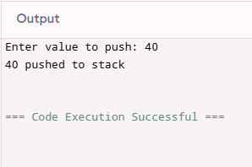
EXP NO21: WRITE A C PROGRAM TO IMPLEMENT STACK OPERATION IN LINKED LIST[POP]
#include <stdio.h>
#include <stdlib.h>
struct Node {
int data;
struct Node *next;
};

struct Node *top = NULL;
void push(int val) {
struct Node *newnode = (struct Node *)malloc(sizeof(struct Node));
newnode->data = val;
newnode->next = top;
top = newnode;
}
void pop() {
if (top == NULL)
printf("Stack Underflow\n");
else {
struct Node *temp = top;
printf("Popped element: %d\n", temp->data);
top = top->next;
free(temp);
}
}
int main() {
push(10);
push(20);
push(30);
pop();
return 0;
}
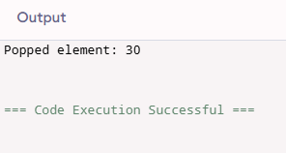
EXP NO22: WRITE A C PROGRAM TO IMPLEMENT STACK OPERATION IN LINKED LIST[DISPLAY]
#include <stdio.h>
#include <stdlib.h>
struct Node {
int data;
struct Node *next;
};
struct Node *top = NULL;
void push(int val) {
struct Node *newnode = (struct Node *)malloc(sizeof(struct Node));
newnode->data = val;
newnode->next = top;
top = newnode;
}
void display() {
if (top == NULL)
printf("Stack is empty\n");
else {
struct Node *temp = top;
printf("Stack elements: ");
while (temp) {
printf("%d ", temp->data);
temp = temp->next;
}
printf("\n");
}
}
int main() {
push(10);
push(20);
push(30);
display();
return 0;

}
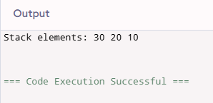
EXP NO 23: Implement a C Program to Print no of nodes in the given linked list
EXP NO 24: Implement a C Program to perform Palindrome using SLL
EXP NO 25: . Implement a C Program to Intersect SLL
EXP NO 26: Implement a C Program to perform linked list – Insertion
EXP NO 27:- Implement a C Program to Reverse – SLL

